The main page is open-able by clicking index.html

THIS IS ONLY HALFLY DONE

You can also open any of those .html / .css / .js files, to check the source code if it does not disgusts you

You may zoom in or out to find the best fit of your screen of the webpage. In my case it is 150% zoom in.

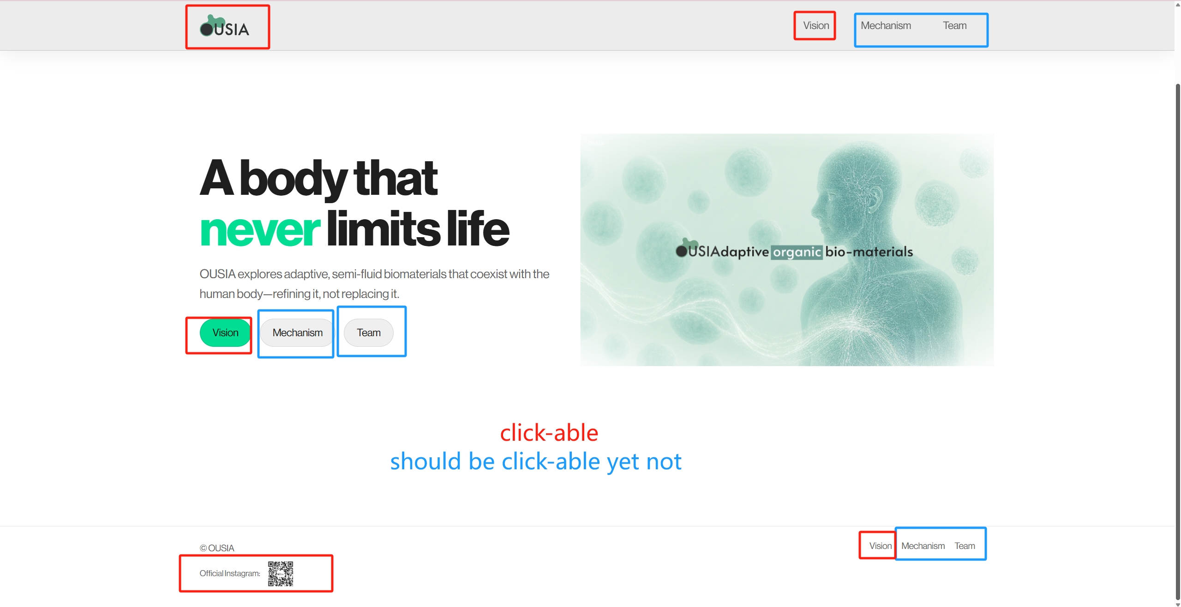

Planning to put more onto it. 